

**Polling District and Polling Place Review 2025**

**Parklands and North Gosforth Ward**

**Parliamentary Constituency:** North

**(Proposed) Polling Districts:** U01, U02, U03, U04, U05, U06

The Local Government Boundary Commission for England are an independent body accountable to Parliament. They are responsible for reviewing councils to make sure their patterns of internal wards are fair and sensible. Their reviews include at least two rounds of public consultation before they make recommendations for change.

The final recommendations were published on 7 January 2025, and the new arrangements apply to local elections from 2026.

As a result of changes to ward boundaries the Acting Returning Officer (ARO) is conducting a review of polling districts and polling places to ensure that they are suitable for the new ward boundaries.

For more information on the local government boundary review visit: <https://www.lgbce.org.uk/all-reviews/newcastle-upon-tyne>

This document provides details of the review, along with the initial recommendations and comments of the Acting Returning Officer (ARO). Also, the election rules require the ARO to decide how many polling stations are required for each polling station and the ARO must allocate electors to the polling stations in such manner as they think most convenient.

These recommendations will be open to all residents, stakeholders, and any interested parties. We shall be seeking representations from local disability groups on the accessibility and suitability of polling places. Any comments should be addressed in the first instance to pollingplaces@newcastle.gov.uk where they will be collated on behalf of the (Acting) Returning Officer.

We considered the following factors:

* **Identifying new polling places:** We will look for new polling places in areas where the existing provision is unsuitable or unavailable.
* **Feedback:** We will consider feedback received following recent elections, consultation from members of the public, elected members, and other stakeholders.
* **Accessibility:** We will try to ensure that every polling place is accessible to electors with disabilities.
* **Facilities**: We will make sure that all electors have such reasonable facilities for voting as are practicable in the circumstances.
* **Elector numbers:** We will try to comply with the Electoral Commission guidance on the maximum number of electors that should be allocated to a polling station which should not exceed 2,250.
* **Future housing developments**: We will consider the impact of proposed housing developments on polling station electorates.

**(Current) Parklands**

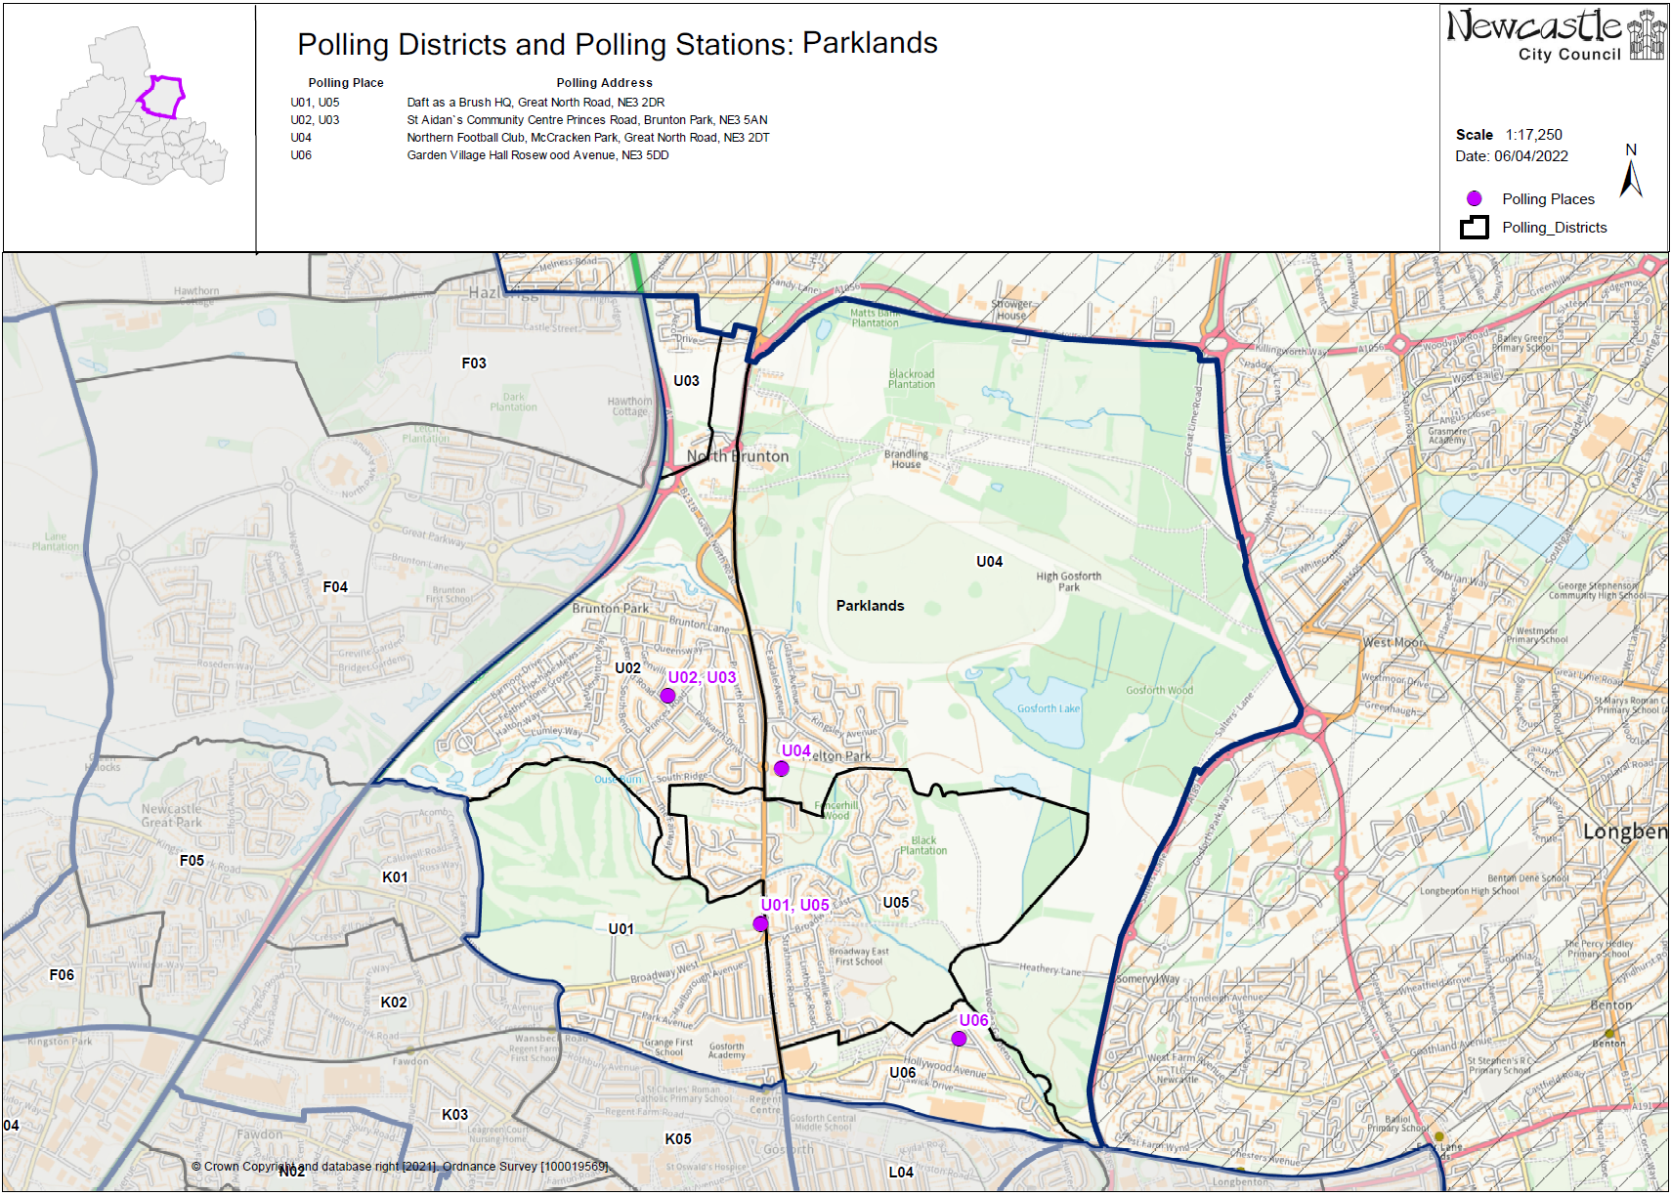This map shows the current ward and polling district boundaries and the polling places.

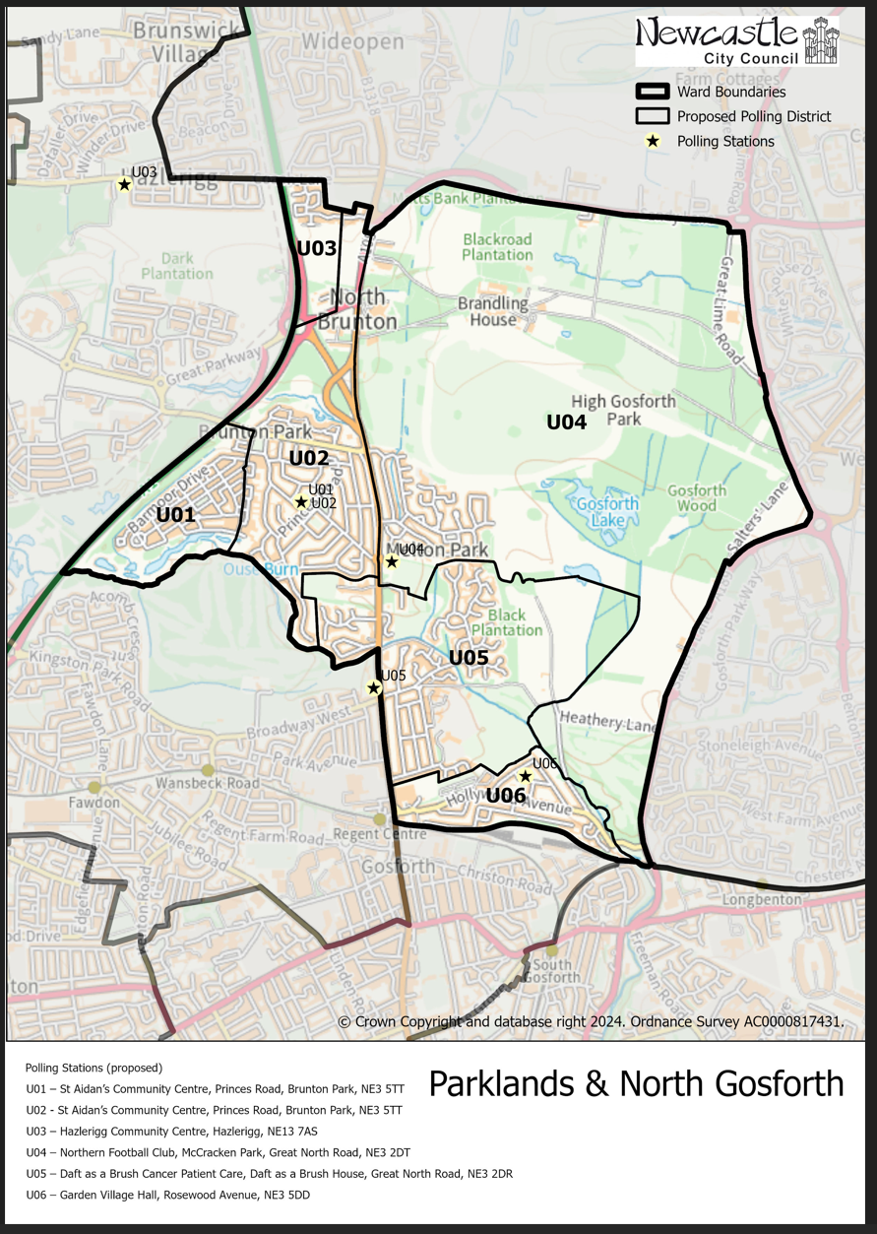**(New)**

**Parklands and North Gosforth Ward**

This map shows the new ward and the proposed polling districts and the proposed polling places.

* U01 – St Aidan’s Community Centre, Princes Road, Bruton Park, NE3 5TT
* U02 – St Aidan’s Community Centre, Princes Road, Bruton Park, NE3 5TT
* U03 – Hazlerigg Community Centre, Hazlerigg, NE13 7AS
* U04 – Northern Football Club, McCracken Park, Great North Road, NE3 2DT
* U05 – Daft as a Brush Cancer Patient Centre, Daft as a Brush House, Great North Road, NE3 2DR
* U06 – Garden Village Hall, Rosewood Avenue, NE3 5DD

**Parklands and North Gosforth Ward**

**Polling District U01**

|  |
| --- |
| **Considerations and Proposals** |
| Part of the current U02 is the proposed U01. Properties to the west of Netherwitton Way and South of Brunton Lane would form the proposed U01 district.  No change to the polling place. St Aidan’s Community Centre is suggested as a double polling station for the proposed U01 and U02 districts. |

|  |  |
| --- | --- |
| **Current Polling District** | **Current Polling Place** |
| U02 (part of) | St Aidan’s Community Centre, Princes Road, Brunton Park, NE3 5TT |

|  |  |  |
| --- | --- | --- |
| **Proposed Polling District** | **Predicted**  **Polling Station Electorate** | **Proposed Polling Place** |
| U01 | 561 | St Aidan’s Community Centre, Princes Road, Brunton Park, NE3 5TT |

|  |
| --- |
| **Preliminary Consultation – Elected Members comments and feedback** |
| No comments received. |

**Parklands and North Gosforth Ward**

**Polling District U02**

|  |  |
| --- | --- |
| **Current Polling District** | **Current Polling Place** |
| U02 (part of) | St Aidan’s Community Centre, Princes Road, Brunton Park, NE3 5TT |

|  |  |  |
| --- | --- | --- |
| **Proposed Polling District** | **Predicted**  **Polling Station Electorate** | **Proposed Polling Place** |
| U02 | 1340 | St Aidan’s Community Centre, Princes Road, Brunton Park, NE3 5TT |

|  |
| --- |
| **Considerations and Proposals** |
| Part of the current U02 would become the proposed U02. Properties to the east of Netherwitton Way would form the proposed U02 district.  No change to the polling place. St Aidan’s Community Centre is suggested as a double polling station for the proposed U01 and U02 districts. |

|  |
| --- |
| **Preliminary Consultation – Elected Members comments and feedback** |
| No comments received. |

**Parklands and North Gosforth Ward**

**Polling District U03**

|  |  |
| --- | --- |
| **Current Polling District** | **Current Polling Place** |
| U03 (full) | St Aidan’s Community Centre, Princes Road, Brunton Park, NE3 5TT |

|  |  |  |
| --- | --- | --- |
| **Proposed Polling District** | **Predicted**  **Polling Station Electorate** | **Proposed Polling Place** |
| U03 | 171 | Hazlerigg Community Centre, Hazlerigg, NE13 7AS |

|  |
| --- |
| **Considerations and Proposals** |
| No changes to the polling district boundary.  Hazlerigg Community Centre is in the proposed E02 district but there is nothing else available in the area.  Location is better suited to the electorate.  Hazlerigg Community Centre is suggested as a double polling station for the proposed districts of U03 and E02. |

|  |
| --- |
| **Preliminary Consultation – Elected Members comments and feedback** |
| No comments received. |

**Parklands and North Gosforth Ward**

**Polling District U04**

|  |  |
| --- | --- |
| **Current Polling District** | **Current Polling Place** |
| U04 (full) | Northern Football Club, McCracken Park, Great North Road, NE3 2DT |

|  |  |  |
| --- | --- | --- |
| **Proposed Polling District** | **Predicted**  **Polling Station Electorate** | **Proposed Polling Place** |
| U04 | 573 | Northern Football Club, McCracken Park, Great North Road, NE3 2DT |

|  |
| --- |
| **Considerations and Proposals** |
| No changes to the polling district boundary.  No changes to the polling place. |

|  |
| --- |
| **Preliminary Consultation – Elected Members comments and feedback** |
| No comments received. |

**Parklands and North Gosforth Ward**

**Polling District U05**

|  |  |
| --- | --- |
| **Current Polling District** | **Current Polling Place** |
| U05 (full) | Daft as a Brush Cancer Patient Care, Daft as a Brush House, Great North Road, NE3 2DR |

|  |  |  |
| --- | --- | --- |
| **Proposed Polling District** | **Predicted**  **Polling Station Electorate** | **Proposed Polling Place** |
| U05 | 993 | Daft as a Brush Cancer Patient Care, Daft as a Brush House, Great North Road, NE3 2DR |

|  |
| --- |
| **Considerations and Proposals** |
| No changes to the polling district boundary.  No change to the polling place.  Daft as a Brush Cancer Patient Care is suggested as a double polling station for the proposed U05 and J04 districts. |

|  |
| --- |
| **Preliminary Consultation – Elected Members comments and feedback** |
| No comments received. |

**Parklands and North Gosforth Ward**

**Polling District U06**

|  |  |
| --- | --- |
| **Current Polling District** | **Current Polling Place** |
| U06 (full) | Garden Village Hall, Rosewood Avenue, NE3 5DD |

|  |  |  |
| --- | --- | --- |
| **Proposed Polling District** | **Predicted**  **Polling Station Electorate** | **Proposed Polling Place** |
| U06 | 617 | Garden Village Hall, Rosewood Avenue, NE3 5DD |

|  |
| --- |
| **Considerations and Proposals** |
| The majority of the current U06 would remain unchanged. The Metro depot is now in the new Gosforth ward, the changes to this district do not affect any residential properties.  No change to the polling place. |

|  |
| --- |
| **Preliminary Consultation – Elected Members comments and feedback** |
| No comments received. |